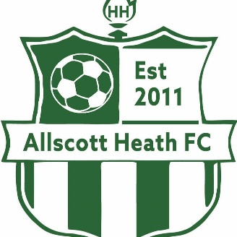

SAFEGUARDING POLICY

Allscott Heath Football Club

It is the aim of this club to ensure that every child or young person who plays football should be able to participate in an enjoyable and safe environment and be protected from abuse. A child or young person is anyone under the age of 18 engaged in any footballing activity (including match officials) All adults associated with this club are to safeguard the welfare of all players and where possible protect them from physical, sexual and emotional harm and from neglect and bullying.

In striving to attain this, the aims of the club are as follows:

- To ensure that the child’s welfare is always considered as paramount
- All young people involved in football have a right to be protected from abuse and harm regardless of their sporting ability, age, gender, disability, culture, language, racial origin, religious beliefs or sexual identity
- The club will treat all suspicions and allegations of abuse and poor practice seriously and will respond swiftly and appropriately
- Working in partnership with other organisations, children and young people and their parents/carers is essential

AHFC acknowledges all young people who participate in football should be able to take part in an enjoyable and safe environment and be protected from poor practice and abuse.

Fair play in football means that everyone connected with football;

- Shows understanding of and respect for the laws of the game
- Supports the belief that the game should be played in an entertaining and positive manner
- Behaves on and off the field of play in a sporting manner towards all others involved, be they players, officials, or spectators regardless of results

AHFC has a duty to safeguard the welfare of all children and young people by protecting them from physical, sexual, or emotional harm and from neglect or bullying. It recognises that the FA’s child protection regulations apply to all in football whether in a paid or voluntary capacity. This includes volunteers, match officials, helpers, football coach, club official or medical staff.

Misconduct & Verbal Abuse

All players, club officials and spectators are reminded that the use of foul language, racial chants and/or remarks are liable conduct bringing the game into disrepute. The appropriate disciplinary action will be taken when instances are brought to the attention of the club, the league or county FA.

PLEASE HELP ENSURE OUR GAMES ARE NOT MARRED BY SUCH BEHAVIOUR!

The club adopts the FA’s Child Protection and Best Practice Guidelines for recruiting volunteers and will adhere to them when recruiting new members. This is covered in a separate policy.

All current AHFC members who have direct access to children and young people will be required to complete a DBS Enhanced Disclosure via the Club Welfare Officer. All decisions will be made for the best interests of children and young people.

This aims to prevent people with a history of relevant and significant offending from having contact with children and young people and the opportunity to influence policies or practice with children or young people. This is to prevent direct sexual or physical harm to children and to minimise risk of ‘grooming’ within football.

AHFC also supports the FA’s Whistleblowing policy which is covered in a separate policy.

The club Welfare officer should be the first point of contact for any members, parents, or guardians regarding concerns for the welfare of any child or young person. They will liaise with the County Welfare Officer and be familiar with the procedures for referring concerns. They will also be proactive in promoting awareness of poor practice and abuse amongst club members and officials.

AHFC acknowledges the FA’s identification of bullying. Bullying is not acceptable within the club. There is a separate policy for this.

Reviewed by Cathy Jones 28/07/2023

